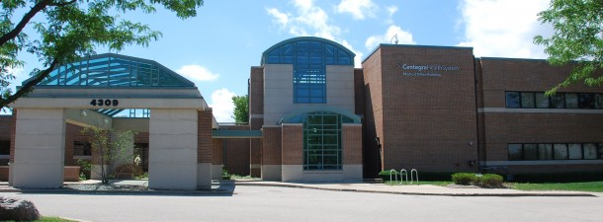

Great opportunity for a sublease of a spacious medical office attached to NIMC at 4309 W Medical Center Dr. McHenry, Illinois 60050

- 3066 square feet
- 4 exam rooms
- Reception area

- Flexible hours
- Private physician office
- Procedure room space available

Contact Donna at 224-535-7011 or hav@illinoispain.com for details
